Dataset 1: Divided Attention & Memory

Scenario Overview
A class investigated whether divided attention reduces memory performance. Participants studied a 20-word list in one of two conditions: full attention (quiet room) or divided attention (simultaneous tone-counting task). Immediately after study, they completed a free-recall test scored out of 20. The figure presents mean recall scores with SD error bars.

Data Summary
Condition | Mean recall score (out of 20) | Error / SD
Full attention | 16.2 | 2.1
Divided attention | 12.3 | 3.5

Figure
Figure 1. Mean recall scores (±SD) for full vs divided attention conditions.
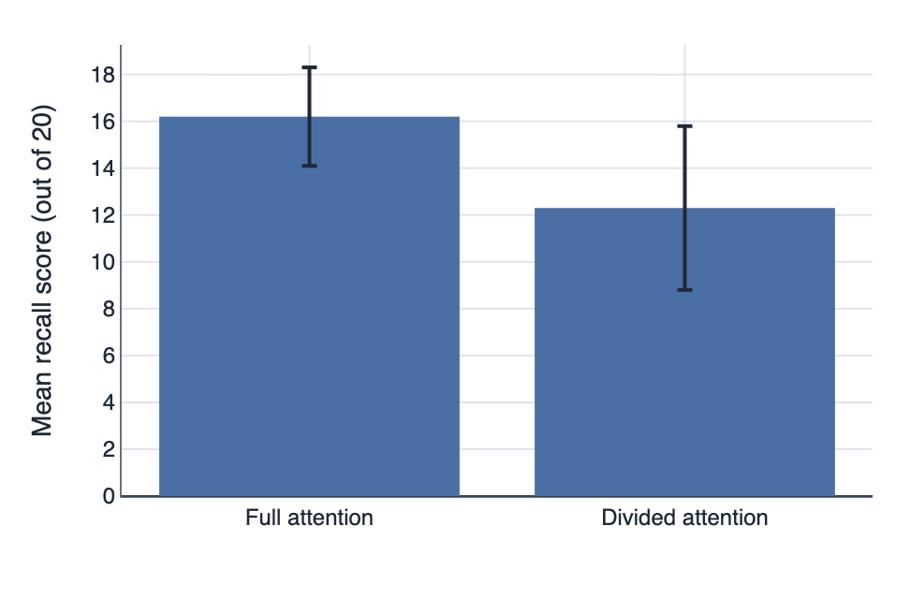

IA1 Practice Questions
- Calculate the mean difference in recall between the full attention and divided attention conditions.

- Determine which condition shows higher variability in recall scores.

- Compare the mean recall scores for the two conditions.

- Identify the pattern in the SD error bars and describe what this suggests about the consistency of the scores.

- Using the p-value provided in the table (p = 0.03), determine if the difference in mean recall is statistically significant. Justify your answer.

- Justify one limitation that could affect this conclusion.

